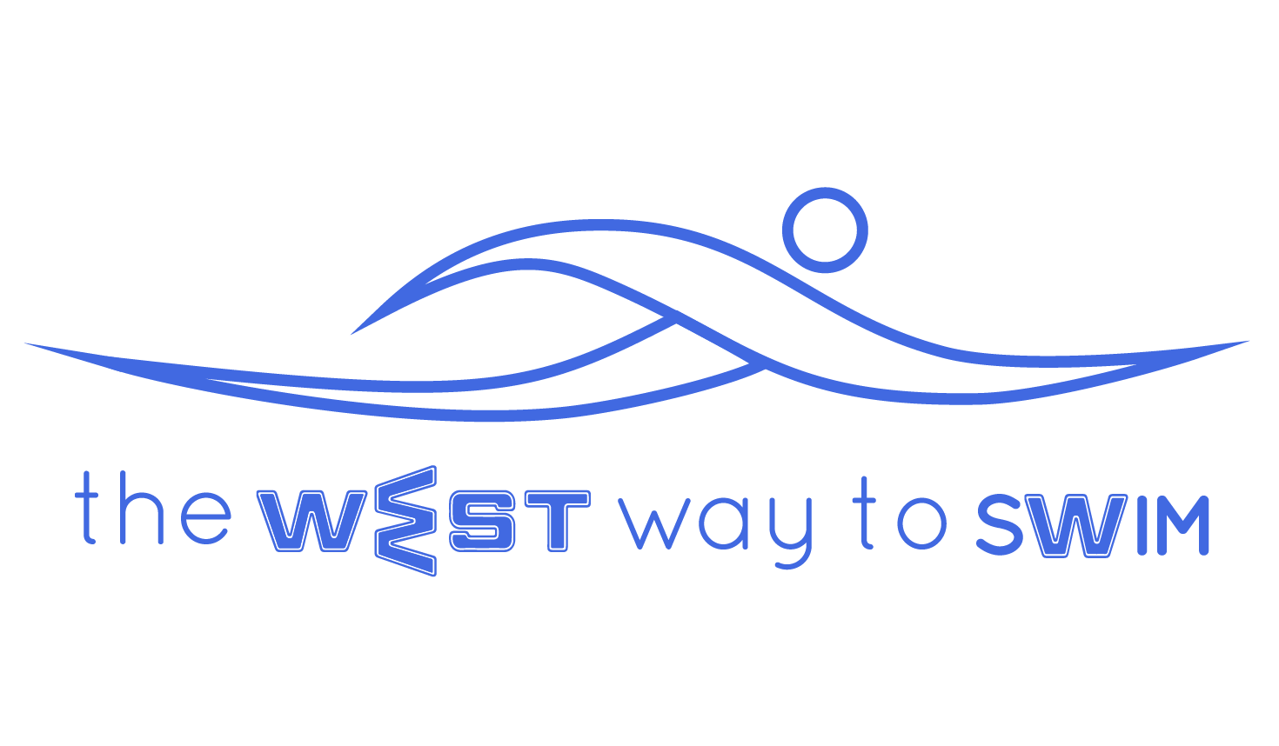
9.0 Goal of session #9: Swim 1000 meters broken in to 200’s at a fixed pace, with slight increase in speed and then return to fixed pace.
No | The Drill & Goals | min | WEST Key Principles | From theory to practice
9.1 | 200-300 warm up, every fourth length - stretched doggie paddle | 8 |  | Swim freestyle with breathing every 3 strokes, and every 4th length swim stretched doggie paddle (like freestyle only hands never leave the water and return to the front under the water) and count strokes, swimming as slowly as possible.
9.2 | 6-8X25 freestyle- minimum strokes per length | 6 | KP- Streamline according to personal WEST.  KP7- End of underwater pull  Moving index finger at the end of the stretch | Swim 25m freestyle with minimum strokes.  Every push off from the wall according to your personal WEST:  A - Glide off the wall with no legwork and stretch to the maximum for 3 sec, then add strokes  B - Glide off the wall while kicking your legs and then add arm strokes.  C - Glide off the wall with 2-4 dolphin moves and then continue swimming.  Every time you reach the end of your stretch you move your index finger, and every time you finish the underwater pull you think of the location of your palm according to your personal WEST:  10 sec rest between every 25m.
9.3 | 4X50 Freestyle- increasing pace from 1-4.  15 sec’s rest between 50’s | 6 |  | Swim 4 times 50m: first time very slow, then a little faster, and the last time should be at apx 85% effort. Try to cut your time short by 2 sec each time.  15 sec rest between each 50m.
9.4 | Timed 200- Do not rush, know your pace.  +  50 slow & easy | 4-8 | KP8- Head position in water (neck neutral)  KP10- Timing of breath  KP12- Body position when breathing. | Swim 200m freestyle thinking of a neutral head facing down and timing your breathing according to your personal WEST:  A - The body starts to transition before the hand enters the water.  B - The body starts to transition just as the palm enters the water.  C - The body starts to transition when the elbow enters the water.  Please send me your 200m time. This is your pace time.  When you finish, swim another 50m very easy.
9.5 | 5X200 Your interval time is 45 seconds more than your time in the previous drill (9.4) | +/- 30 |  | Swim 5 times 200m on a fixed exit time and 65-75% effort.  *If in the previous drill (9.4) we did 4:49 min for 200m, our exit time will be every 5:30 or 5:45, whichever we choose depending on how much rest we need, and that time will remain constant.
9.6 | 6-8X25 slow and long. At the end of every 25, two streamline stretches. | 6 | 1.7.3 - streamline stretch | Swim 6-8 times 25m, slow and long, and count your strokes. At the end of every 25, make two streamline stretches, apx 30 seconds of stretching between every 25m.
9.7 | 7 minutes of hand stretching placing emphasis on streamline, inverted streamline and arms behind your back. | 7 | 1.7.3 - Streamline stretch  4.5.1 - Inverted streamline stretch  1.7.2 - Arms behind your back on the wall | 7 minutes of hand stretching, placing emphasis on opening our chest and elongating our upper body.  streamline, inverted streamline and arms behind your back on the wall.
9.8 In this session you will already be able to estimate your time for a continuous 1000 meters swim. You take your pace for the 200 meters, add thirty seconds and times it by five. For example: If you swam your 200 meters in 5:30, to swim 1000 meters will take you 30 minutes(6minX5) and the entire session will take between one and one and a half hours.
9.9 Weekly Tip: It is very important to be aware of your stroke rate as a measure of your efficiency in the water (which regresses the more tired you get). If you see that your stroke rate rises by more than 2 strokes per length, it is time to stop, stretch lightly and continue. It is more important to swim correctly than swim long distances incorrectly. The habits you implement will stay with you in the future- Ensure they are correct.

